**Assignment**: (Restful APi) - Assignment ID: 11_RestFulAPI_Assignment3

**Develop an angular client to consume the web services developed in the assignment (11_RestFulAPI_Assignment1)**

1. Is a new book added?

2. What if the book is null for add book service?

3. Delete book operation with existing id.

4. Delete book operation with non-exiting id

5. Update book with existing id

6. Update book operation with non existing id.

7. Get a book operation with existing id

8. Get a book operation with non existing id.

**Code**:



1. **What if the book is null for add book service?** (Without Book Title)

Result: Failed

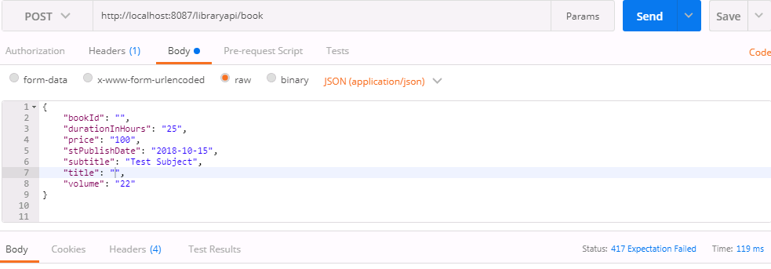

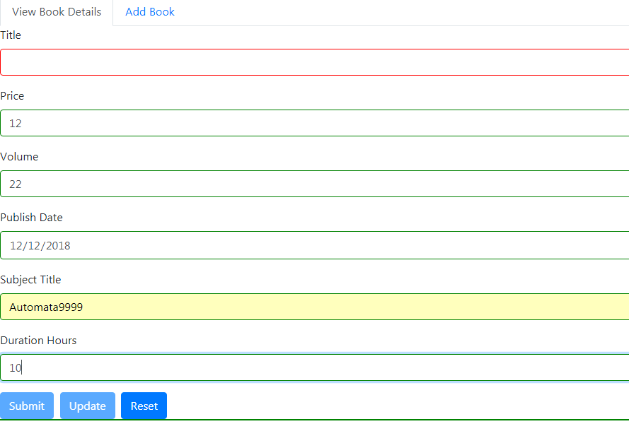

2. **Delete book operation with existing id.**

Result: Gone

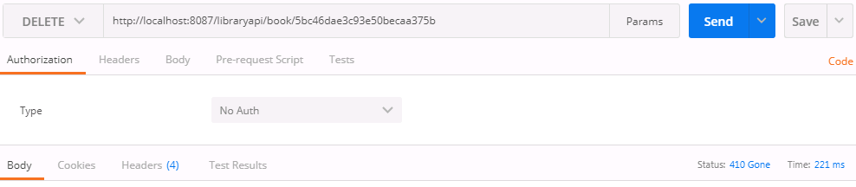

3. **Delete book operation with non-exiting id**

Result: Exception

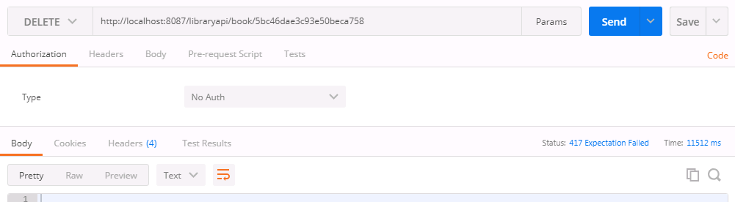

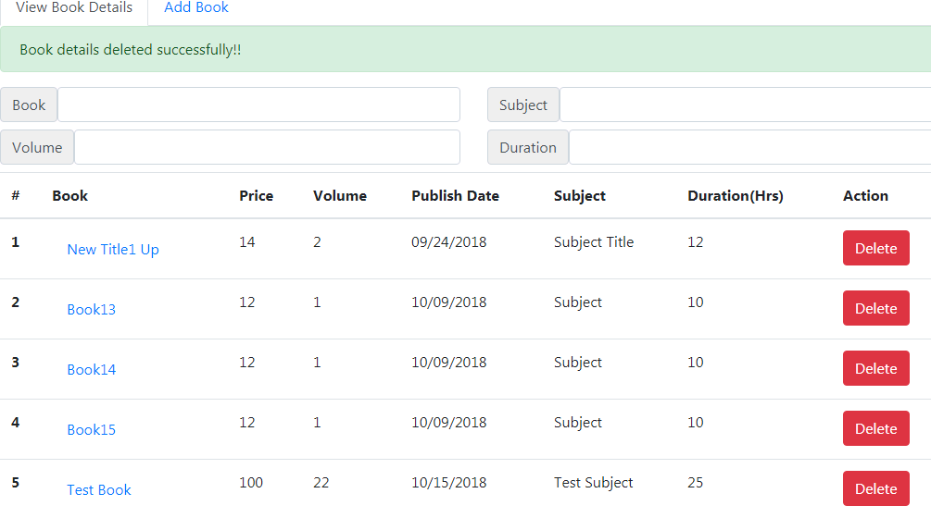

4. **Update book with existing id**

Result: Success

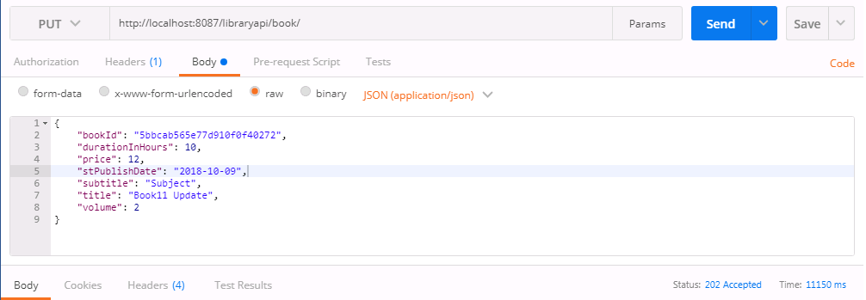

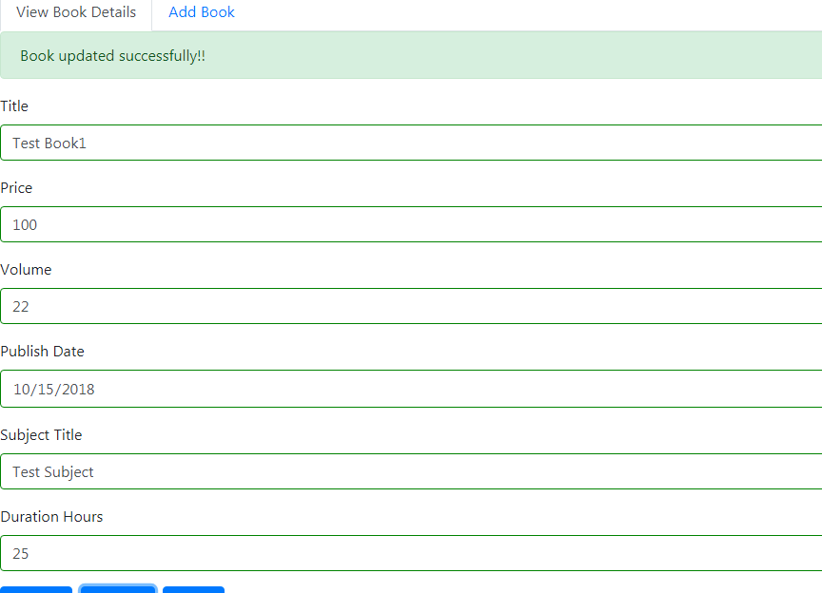

5. **Update book operation with non existing id**

Result: Exception

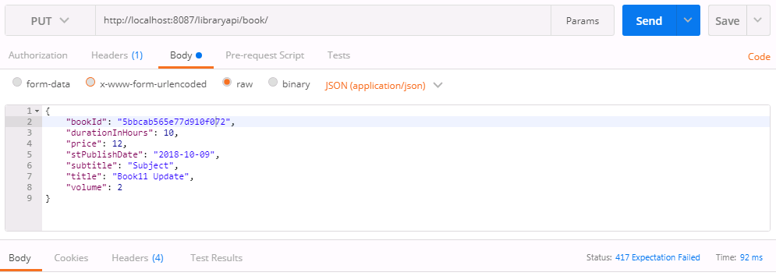

6. **Get a book operation with existing id**

Result: Success

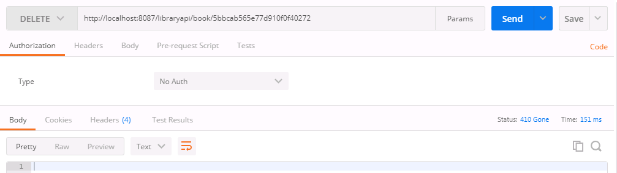

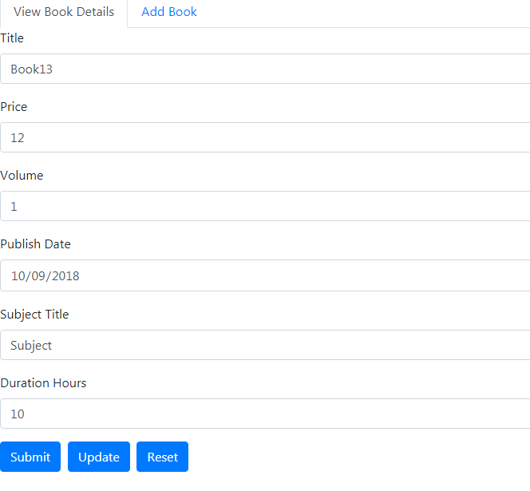

7. **Get a book operation with non existing id.**

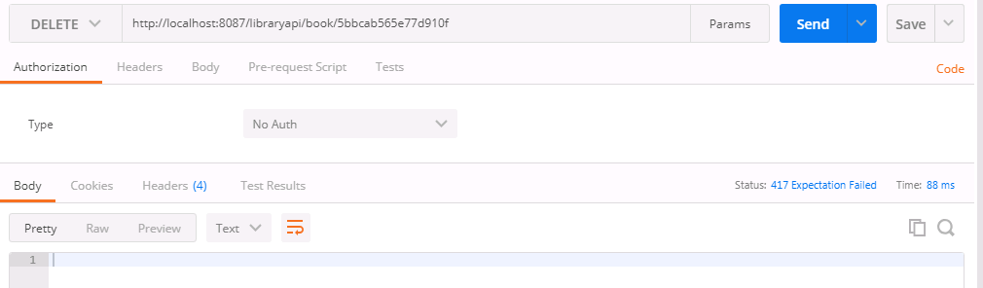

**Mongo DB Command prompt**

